CMPT 431

Assignment1

Report

Collaborators: Brian Pak Rafay Tanzeel

Student ID: 30116802

SFU ID: [bpak@sfu.ca](mailto:bpak@sfu.ca) [rtanzeel@sfu.ca](mailto:rtanzeel@sfu.ca)

Pre-assignment:

Data used for the parallel version of SOR program

Number of Processors and Elapsed time - x-axis: Number of processors

in each trial (measured in sec) y-axis: Speedup

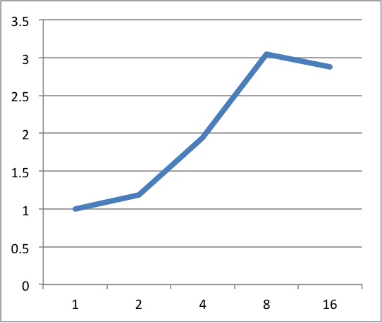Input: i=100 m=4000 n=500

p1 1.04 0.99 1.05

p2 0.83 0.86 0.91

p4 0.60 0.49 0.50

p8 0.31 0.33 0.37

p16 0.32 0.36 0.39

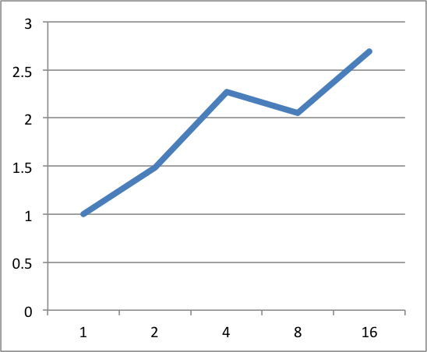Input: i=200 m=6000 n=500

p1 3.18 3.09 2.99

p2 2.20 2.02 2.01

p4 1.38 1.25 1.45

p8 1.45 1.51 1.55

p16 1.05 1.17 1.22

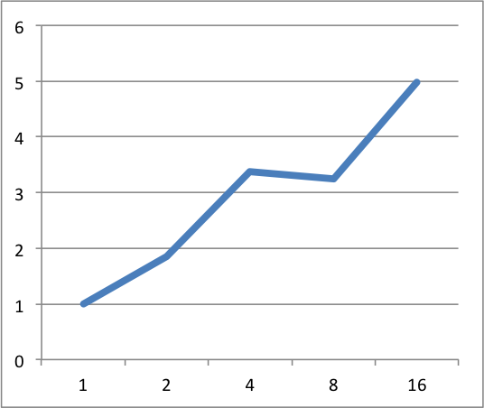Input: i=700 m=6000 n=500

p1 10.89 11.11 10.50

p2 6.02 5.75 5.83

p4 3.07 3.50 3.07

p8 3.33 3.45 3.24

p16 2.22 2.04 2.27

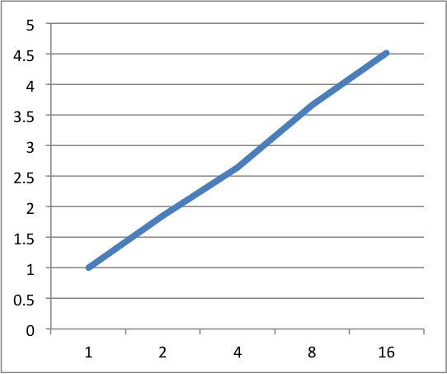

Input: i=1000 m=7000 n=500

p1 17.85 18.21 17.92

p2 9.89 9.54 9.65

p4 6.73 6.72 7.05

p8 4.91 4.74 5.08

p16 3.54 3.70 4.70

The machine used to test the parallel version of SOR program is amoeba-n3. Different inputs (various iterations and matrix sizes) as well as different number of CPU cores are utilized to see and record the behaviors of the parallelized program and the speedup in performance.

As we can see from the charts, the speedup increases, as more numbers of CPU cores are available. However, from diagrams 2 and 3, when we increase the numbers of cores from 4 to 8, we actually see a decrease in speedup. This is because, the threads are currently being assigned to the CPU cores randomly; they are not assigned to specific cores. This could be a problem if the system has multiple sockets and each socket has its own cores. And the CPU of amoeba-n3 is this case.

Illustration:

Amoeba-n3

|  |  |
| --- | --- |
| P0, P2, P4, P6  P8, P10, P12, P14  P16, P18, P20, P22 | P1, P3, P5, P7  P9, P11, P13, P15  P17, P19, P21, P23 |

Socket1 Socket2

When variables are cached in a core in one socket and are shared to a core in the other socket will create overhead because of locality. It simply takes more time to reach and talk to the cores in a different region. So, as the thread binding method is not used, it directly affects to the performance of the parallel SOR program.